Student : Catargiu Andreea - Alexandra
Group : 30238

sds

Table of Contents
1
1
Student: 1
Table of Contents 2
1. Requirements Analysis 3
1.1Assignment Specification 3
1.2Functional Requirements 3
1.3Non-functional Requirements 3
2. Use-Case Model 3
Use case: <use case goal> 3
Level: <one of: summary level, user-goal level, sub-function> 3
Primary actor: <a role name for the actor who initiates the use case> 3
Main success scenario: <the steps of the main success scenario from trigger to goal delivery> 3
Extensions: <alternate scenarios of success or failure> 3
] 3
3. System Architectural Design 3
4. UML Sequence Diagrams 3
5. Class Design 3
6. Data Model 3
7. System Testing 4
8. Bibliography 4

1. Requirements Analysis

Assignment Specification HELLO
The assignment is about building a book management service. A user will be able to create an account, choose a payment plan and login to search the book library.
Payments can be done via cash only policy and need to be validated by library staff.
The library is managed by staff and can be filtered by release date, author, title and genre.
If a book is available a user can add it to your library. If not, the user can join a waiting list. Once a book has been read by a user, it can be returned via the online library return function. The assigns the book to the next user in the waiting list after validation of the return by library staff.
The service also provides users with dynamic recommendations based on latest trends – popular borrowed books – or user defined interests by genre or topic.

Functional Requirements
The functional requirements of the assignment:
    - create an account
    - choose a payment plan
    - login
    - the books can be filtered by release date, author, title and genre
    - add a book to library
    - return a book
    - book recommendations
    - The staff will manage the library. They will have to validate the payments of the users, the return of a book.
    - If a user wants a book that is not available, he can join a waiting list. When the list will be returned, it will be assigned to the first person in the waiting list.

Non-functional Requirements

2. Use-Case Model
[Create the use-case diagrams and provide one use-case description (according to the format below).
Use-Case description format:

Use case: <use case goal>

Level: <one of: summary level, user-goal level, sub-function>

Primary actor: <a role name for the actor who initiates the use case>

Main success scenario: <the steps of the main success scenario from trigger to goal delivery>

Extensions: <alternate scenarios of success or failure>

]

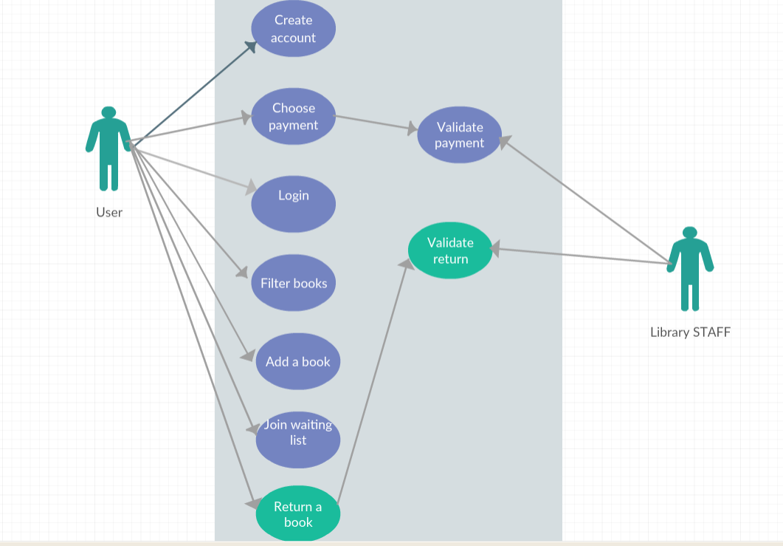
Use case:
Level: Summary level
Primary actor: Customer/Staff
Main success scenario: The customer can login successfully ( or if he does not have an account, he is able to create an account and the staff validates his payment). He wants to borrow a book, and filter the books, finds the book he wants available and he borrows it. After he reads the book, he makes a request to return it, and the stuff accepts his request.
Extensions: If the customer does not have an account and the staff does not accept his request for the payment, then the will not be able to create an account.

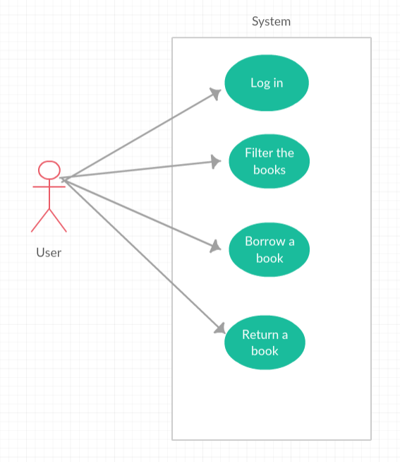
Use case: Borrow a book
Level: User-Goal Level
Primary actor: Customer
Main success scenario: After the customer logs in successfully, he will be able to see all the books, and to filter them as he wants, after title, genre, author and release date. After he decides what he wants to borrow, if the book is available, he can borrow it. After he reads it, he can return it.
Extensions: If the book the customer wants to borrow is not available, he has to wait and join a waiting list until the book becomes available for him.

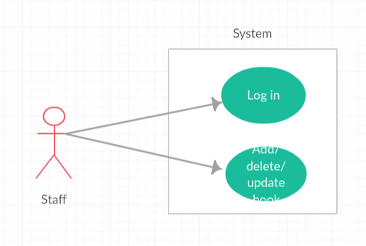
Use case: Manage library
Level: Sub-function
Primary actor: staff
Main success scenario: After the staff logs in successfully, he will be able to add, delete or update any book he wants.
Extensions: If he types the wrong password or he does not have a staff account, then he will not be able to log in,

3. System Architectural Design

3.1 Architectural Pattern Description

The architectural pattern required for this assignment is Layered Architectural Pattern. Components within the layered architecture pattern are organized into horizontal layers, each layer performing a specific role within the application. Most layered architectures consist of four standard layered layers: presentation, business, persistence and database.
Each layer of the layered architecture pattern has a specific role and responsibility within the application:
  - Presentation Layer (GUI): this layer has the user interface implemented. It uses the business layer for all operations.
  - Business Layer (bll): this layer uses the dataAccess layer to manipulate data in the database, to provide operations for the presentation layer.
  - Persistence Layer (dataAccess): this layer uses the dataAccess layer to make CRUD operations on the database.
  - Database Layer (Model): this layer has classes representing the tables in the database.

3.2 Diagrams

The diagram for the layered architecture:
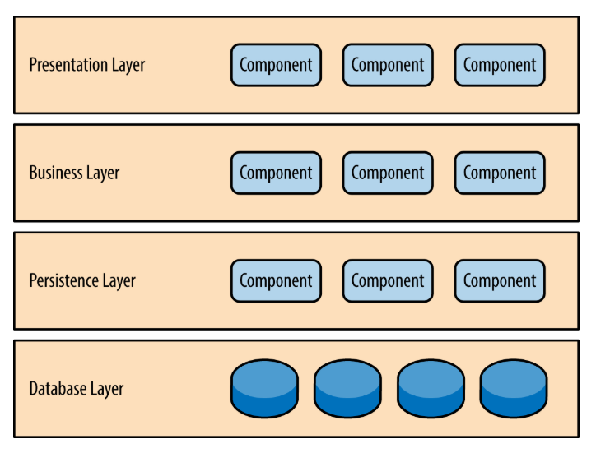

Package diagram:

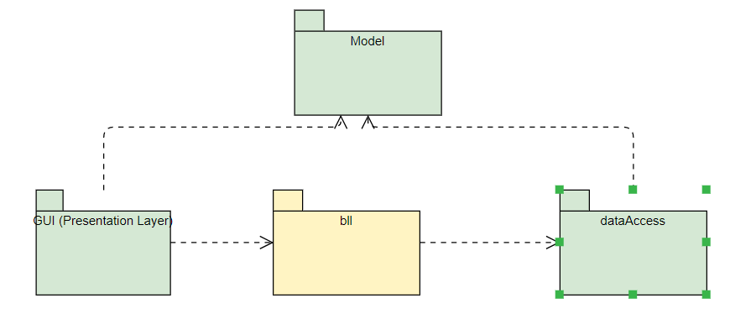
Component diagram:

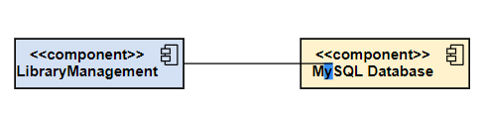
Deployment diagram:

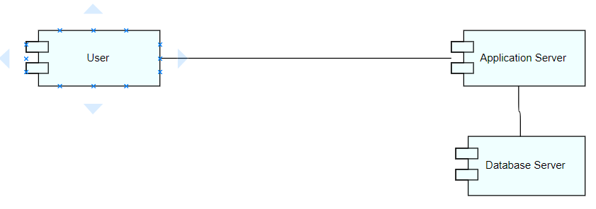

4. UML Sequence Diagrams

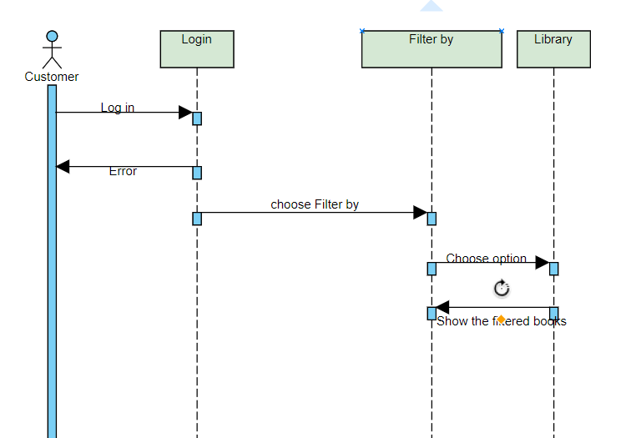

5. Class Design

5.1 Design Patterns Description

The design pattern used in this assignment is Factory Design Pattern. Factory method patern is a creational pattern hat uses factory methods to deal with the problem of creating objects without having to specify the exact class of the object that will be created. This is done by creating objects by calling a factory method—either specified in an interface and implemented by child classes, or implemented in a base class and optionally overridden by derived classes—rather than by calling a constructor.

5.2 UML Class Diagram

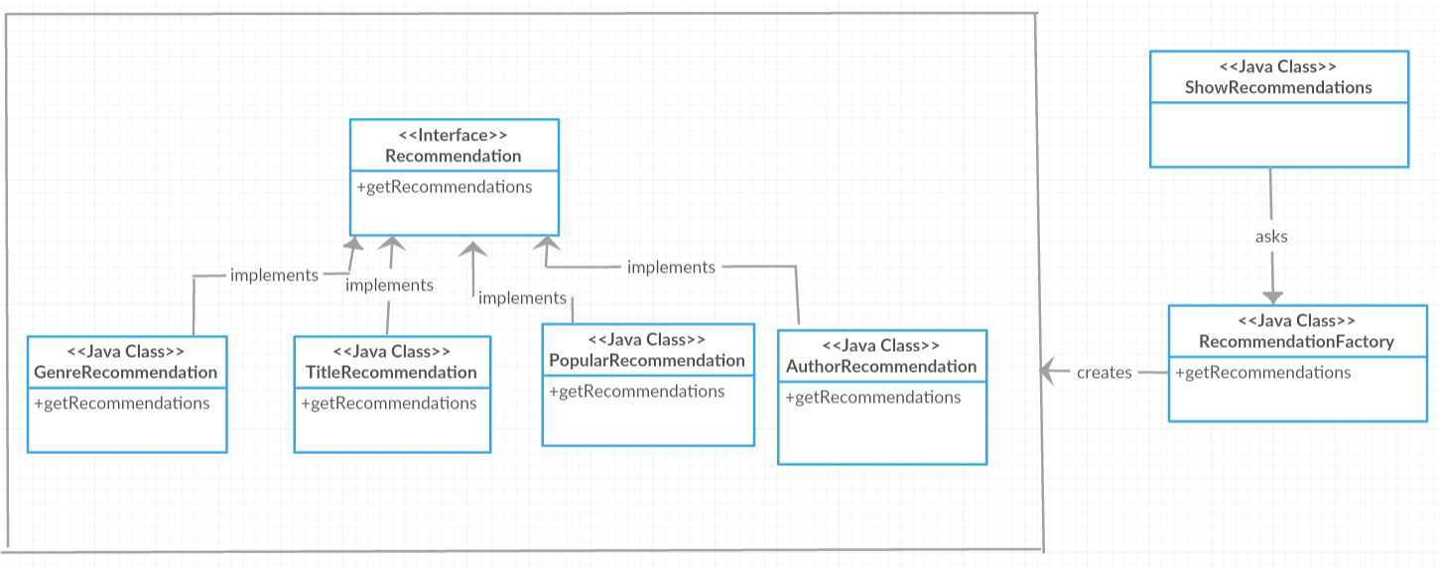

6. Data Model

Our data is composed from 4 tabels: One with customers, the second with the staff, the third one with books, and the last one with borrowed books:

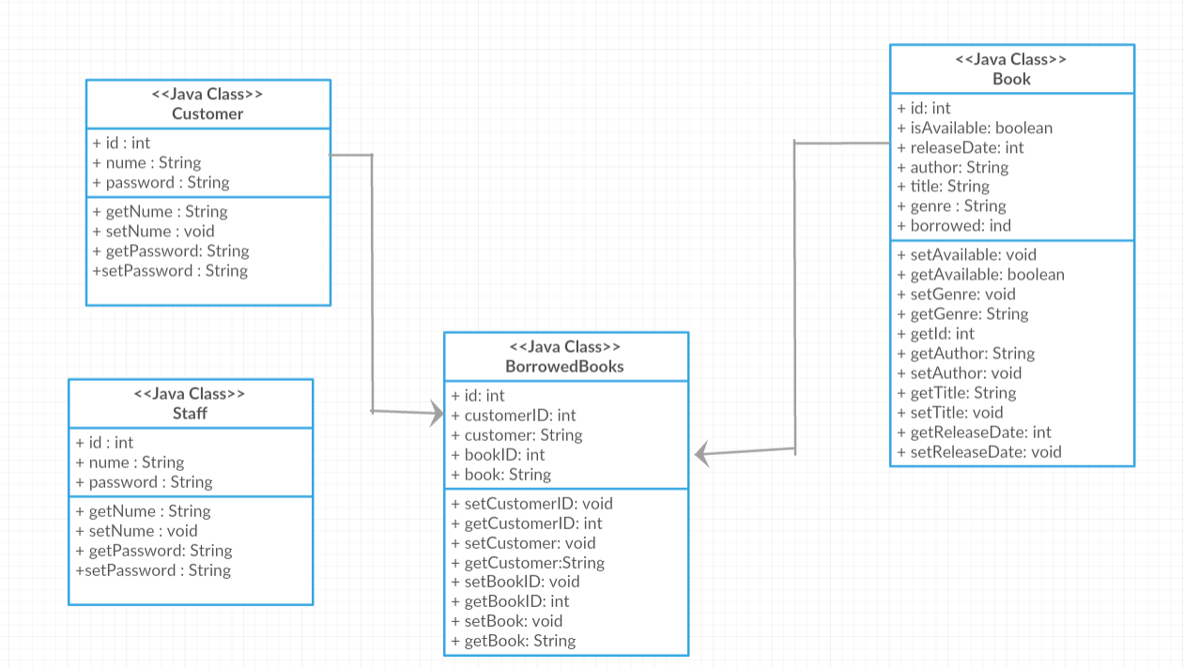

7. System Testing
[Present the used testing strategies (unit testing, integration testing, validation testing) and testing methods (data-flow, partitioning, boundary analysis, etc.).]

8. Bibliography
[1] https://wiki.nci.nih.gov/display/seminfra/Use+Case+Leveling+Definitions
[2]https://www.oreilly.com/library/view/software-architecture- patterns/9781491971437/ch01.html
[3] https://en.wikipedia.org/wiki/Factory_method_pattern

